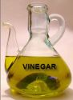
Sore throat? Just mix 1/4 cup of vinegar with 1/4 cup of honey and take 1 tablespoon six times a day. The vinegar kills the bacteria.

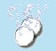
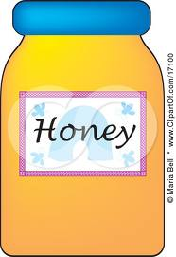
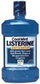
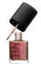
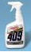
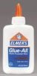
Cure urinary tract infections with Alka-Seltzer. Just dissolve two tablets in a glass of water and drink it at the onset of the symptoms. Alka-Seltzer begins eliminating urinary tract infections almost instantly-even though the product has never been advertised for this use.
Honey remedy for skin blemishes... cover the blemish with a dab of honey and place a Band-Aid over it. Honey kills the bacteria, keeps the skin sterile, and speeds healing. Works overnight.
Listerine therapy for toenail fungus:Get rid of unsightly toenail fungus by soaking your toes in Listerine Mouthwash. The powerful antiseptic leaves your toenails looking healthy again.
Easy eyeglass protection... to prevent the screws in eyeglasses from loosening, apply a small drop of Maybelline Crystal Clear Nail Polish to the threads of the screws before tightening them.
Cleaning liquid that doubles as bug killer... if menacing bees, wasps, hornets, or yellow jackets get in your home and you can't find the insecticide, try a spray of Formula 409. Insects drop to the ground instantly.
Smart splinter remover: Just pour a drop of Elmer's Glue- All over the splinter, let dry, and peel the dried glue off the skin. The splinter sticks to the dried glue.

