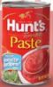
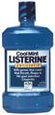
Hunt's Tomato Paste boil cure... cover the boil with Hunt's Tomato Paste as a compress. The acids from the tomatoes soothe the pain and bring the boil to a head.

Balm for broken blisters... to disinfect a broken blister, dab on a few drops of Listerine, a powerful antiseptic.

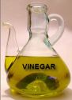
Vinegar to heal bruises... soak a cotton ball in white vinegar and apply it to the bruise for 1 hour. The vinegar reduces the blueness and speeds up the healing process.


Quaker Oats for fast pain relief... it's not for breakfast any more! Mix 2 cups of Quaker Oats and 1 cup of water in a bowl and warm in the microwave for 1 minute, cool slightly, and apply the mixture to your hands for soothing relief from arthritis pain.

